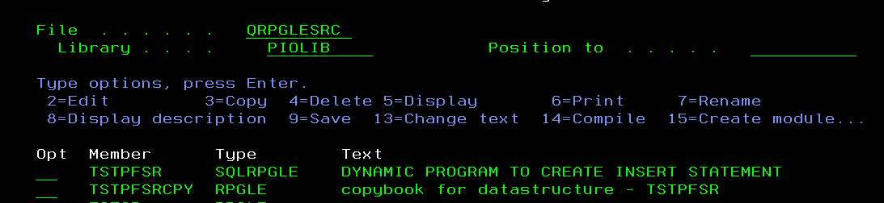

File where table names will be stored – TFLNMP

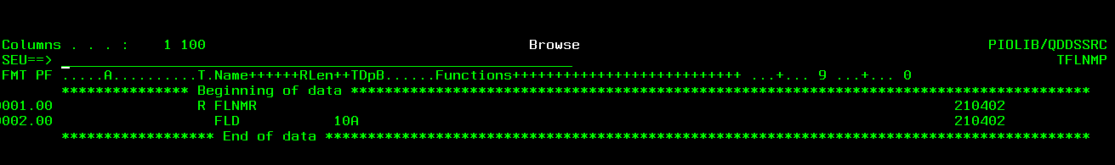

Table being used for testing – TSTADPF

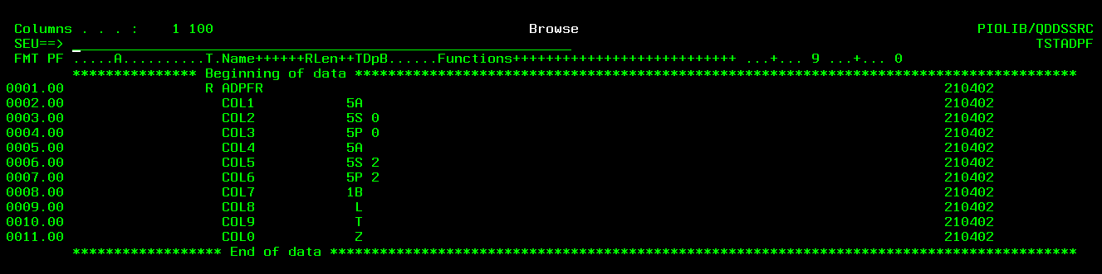

Data in file TSTADPF – 1 record only

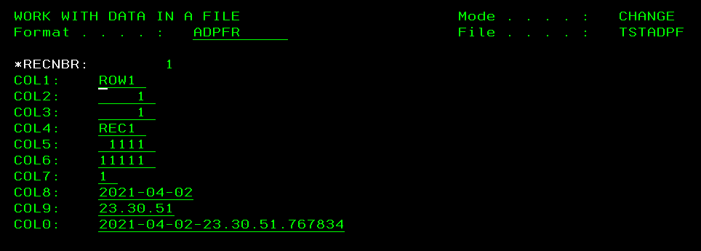

# Program sources



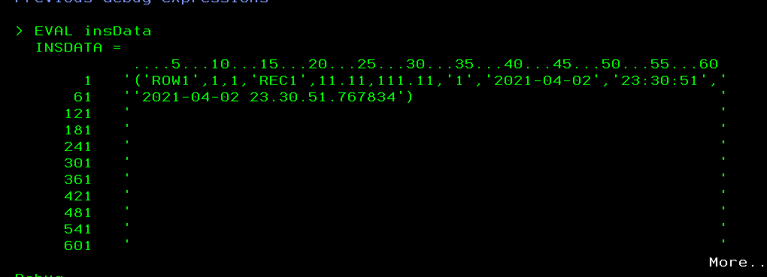

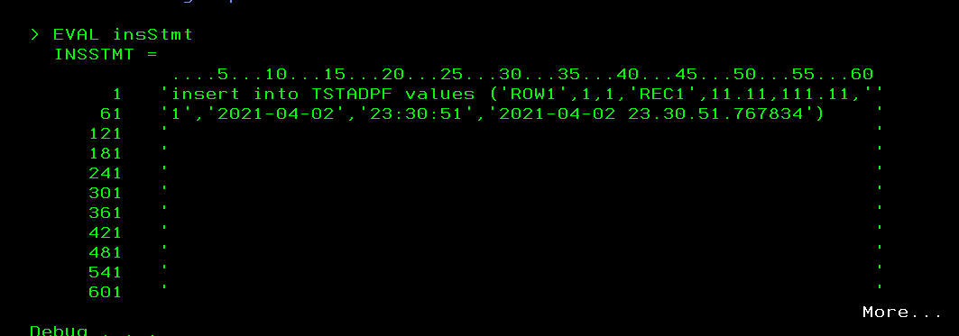

Data type format supported by MySQL for date time timestamp:

[MySQL :: MySQL 8.0 Reference Manual :: 9.1.3 Date and Time Literals](https://dev.mysql.com/doc/refman/8.0/en/date-and-time-literals.html#:~:text=For%20example%2C%20to%20insert%20the,%27%20%2C%20or%20%27ss%27%20.)